Market Basket Analysis
import pandas as pd
import numpy as np
# Set the seed for reproducibility
np.random.seed(42)
# Generate random data for market basket analysis
num_transactions = 500
num_items = 10 # 10 different products
# Randomly generate customer transactions
# Each customer can buy 1 to 5 items from the list of 10 products
product_list = ['ProductA', 'ProductB', 'ProductC', 'ProductD', 'ProductE',
'ProductF', 'ProductG', 'ProductH', 'ProductI', 'ProductJ']
# Create a function to simulate customer purchases
def generate_transactions(num_transactions, num_items):
transactions = []
for _ in range(num_transactions):
num_products = np.random.randint(1, 6) # Each customer buys 1 to 5 items
purchased_items = np.random.choice(product_list, num_products, replace=False)
transactions.append(purchased_items)
return transactions
# Generate the dataset of transactions
transactions = generate_transactions(num_transactions, num_items)
# Create a DataFrame where each row represents a transaction
# Each column will represent a product, and the value will be 1 if the product is purchased, 0 otherwise.
transaction_matrix = np.zeros((num_transactions, num_items))
# Fill the transaction matrix with the product purchases
for i, transaction in enumerate(transactions):
for product in transaction:
product_index = product_list.index(product)
transaction_matrix[i, product_index] = 1
# Create a DataFrame for the transaction data
transaction_df = pd.DataFrame(transaction_matrix, columns=product_list)
# Save to CSV
transaction_df.to_csv('market_basket_analysis.csv', index=False)
# Display the first few rows of the dataset
transaction_df.head()
# Calculate WCSS (Within-Cluster Sum of Squares) for different numbers of clusters
wcss = []
for i in range(1, 11):
kmeans = KMeans(n_clusters=i, random_state=42)
kmeans.fit(scaled_data)
wcss.append(kmeans.inertia_)
# Plot the Elbow Curve to determine the optimal K
plt.plot(range(1, 11), wcss)
plt.title('Elbow Method for Optimal K')
plt.xlabel('Number of Clusters (K)')
plt.ylabel('WCSS')
plt.show()
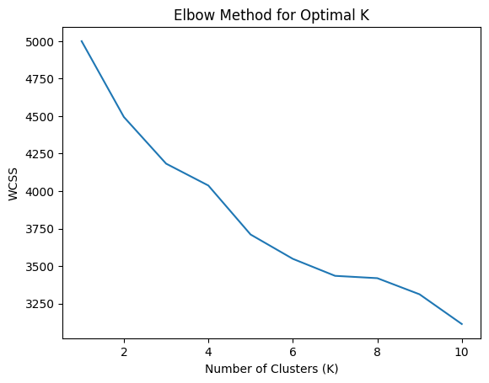
# Apply K-Means with the selected K (e.g., K=4)
kmeans = KMeans(n_clusters=4, random_state=42)
clusters = kmeans.fit_predict(scaled_data)
# Add the cluster labels to the original dataset
data['Cluster'] = clusters
# Show the first few rows with cluster labels
data.head()
# Analyze the frequency of products purchased by each cluster
cluster_insights = data.groupby('Cluster').mean()
print(cluster_insights)
ProductA ProductB ProductC ProductD ProductE ProductF ProductG \
Cluster
0 0.359756 0.176829 0.231707 0.000000 0.237805 0.250000 0.560976
1 0.284615 0.230769 0.246154 1.000000 0.276923 0.284615 0.307692
2 0.129310 0.405172 0.155172 0.017241 0.508621 0.112069 0.017241
3 0.300000 0.544444 0.611111 0.066667 0.266667 0.733333 0.088889
ProductH ProductI ProductJ
Cluster
0 0.256098 0.207317 0.396341
1 0.238462 0.400000 0.330769
2 0.077586 0.543103 0.163793
3 0.600000 0.222222 0.344444

import pandas as pd
import numpy as np
from sklearn.cluster import KMeans
from sklearn.preprocessing import StandardScaler
import matplotlib.pyplot as plt
# Step 1: Load the dataset (use your own path for the CSV file)
data = pd.read_csv('market_basket_analysis.csv')
# Step 2: Preprocess the data (Scale the data to normalize it)
scaler = StandardScaler()
scaled_data = scaler.fit_transform(data)
# Step 3: Elbow Method to determine the optimal number of clusters (K)
wcss = []
for i in range(1, 11):
kmeans = KMeans(n_clusters=i, random_state=42)
kmeans.fit(scaled_data)
wcss.append(kmeans.inertia_)
# Plot the Elbow Method to find the optimal K
plt.plot(range(1, 11), wcss)
plt.title('Elbow Method for Optimal K')
plt.xlabel('Number of Clusters')
plt.ylabel('WCSS')
plt.show()
# Step 4: Apply K-Means with the selected number of clusters (let's assume K=4)
optimal_k = 4 # Based on the elbow plot (you can adjust this)
kmeans = KMeans(n_clusters=optimal_k, random_state=42)
clusters = kmeans.fit_predict(scaled_data)
# Step 5: Add the cluster labels to the original dataset
data['Cluster'] = clusters
# Step 6: Show the first few rows of the dataset with cluster labels
print(data.head())
# Step 7: Cluster insights (mean of features within each cluster)
cluster_insights = data.groupby('Cluster').mean()
print("\nCluster Insights (Average Features per Cluster):")
print(cluster_insights)
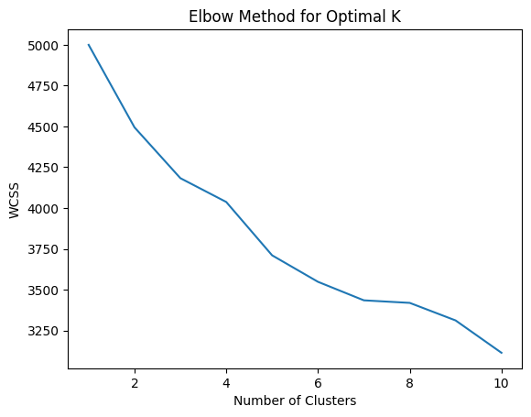
ProductA ProductB ProductC ProductD ProductE ProductF ProductG \
0 1.0 0.0 0.0 1.0 0.0 0.0 0.0
1 1.0 0.0 1.0 0.0 0.0 0.0 0.0
2 0.0 1.0 1.0 0.0 0.0 0.0 1.0
3 0.0 1.0 0.0 0.0 0.0 0.0 0.0
4 0.0 0.0 1.0 0.0 0.0 0.0 0.0
ProductH ProductI ProductJ Cluster
0 0.0 1.0 1.0 1
1 0.0 1.0 0.0 2
2 1.0 0.0 0.0 3
3 0.0 1.0 0.0 2
Cluster Insights (Average Features per Cluster):
ProductA ProductB ProductC ProductD ProductE ProductF ProductG \
Cluster
0 0.359756 0.176829 0.231707 0.000000 0.237805 0.250000 0.560976
1 0.284615 0.230769 0.246154 1.000000 0.276923 0.284615 0.307692
2 0.129310 0.405172 0.155172 0.017241 0.508621 0.112069 0.017241
3 0.300000 0.544444 0.611111 0.066667 0.266667 0.733333 0.088889
ProductH ProductI ProductJ
Cluster
0 0.256098 0.207317 0.396341
1 0.238462 0.400000 0.330769
2 0.077586 0.543103 0.163793
3 0.600000 0.222222 0.344444
import pandas as pd
import numpy as np
from sklearn.cluster import KMeans
from sklearn.preprocessing import StandardScaler
import matplotlib.pyplot as plt
# Step 1: Generate synthetic data (Retail customers with product purchase behavior)
# Assume 5 features, mimicking purchasing behavior
np.random.seed(42)
# Generate random data with three clear clusters
cluster_1 = np.random.normal(loc=[50, 200, 0.2, 30, 1], scale=10, size=(100, 5))
cluster_2 = np.random.normal(loc=[150, 300, 0.5, 50, 2], scale=15, size=(100, 5))
cluster_3 = np.random.normal(loc=[300, 500, 0.8, 80, 3], scale=20, size=(100, 5))
# Combine the clusters to form the dataset
data = np.vstack([cluster_1, cluster_2, cluster_3])
# Convert to DataFrame for better readability
columns = ['ProductA', 'ProductB', 'ProductC', 'ProductD', 'ProductE']
data_df = pd.DataFrame(data, columns=columns)
# Step 2: Preprocess the data (Scale the data to normalize it)
scaler = StandardScaler()
scaled_data = scaler.fit_transform(data_df)
# Step 3: Elbow Method to determine the optimal number of clusters (K)
wcss = []
for i in range(1, 11):
kmeans = KMeans(n_clusters=i, random_state=42)
kmeans.fit(scaled_data)
wcss.append(kmeans.inertia_)
# Plot the Elbow Method to find the optimal K
plt.plot(range(1, 11), wcss)
plt.title('Elbow Method for Optimal K')
plt.xlabel('Number of Clusters')
plt.ylabel('WCSS')
plt.show()
# Step 4: Apply K-Means with the selected number of clusters (e.g., K=3)
optimal_k = 3 # Based on the elbow plot (K=3)
kmeans = KMeans(n_clusters=optimal_k, random_state=42)
clusters = kmeans.fit_predict(scaled_data)
# Step 5: Add the cluster labels to the original dataset
data_df['Cluster'] = clusters
# Step 6: Show the first few rows of the dataset with cluster labels
print(data_df.head())
# Step 7: Cluster insights (mean of features within each cluster)
cluster_insights = data_df.groupby('Cluster').mean()
print("\nCluster Insights (Average Features per Cluster):")
print(cluster_insights)
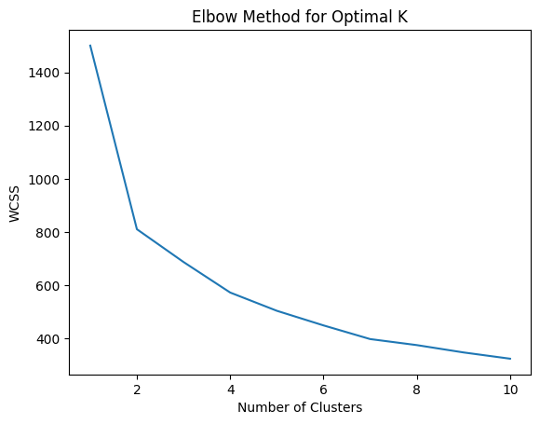
ProductA ProductB ProductC ProductD ProductE Cluster
0 54.967142 198.617357 6.676885 45.230299 -1.341534 2
1 47.658630 215.792128 7.874347 25.305256 6.425600 2
2 45.365823 195.342702 2.619623 10.867198 -16.249178 2
3 44.377125 189.871689 3.342473 20.919759 -13.123037 2
4 64.656488 197.742237 0.875282 15.752518 -4.443827 2
Cluster Insights (Average Features per Cluster):
ProductA ProductB ProductC ProductD ProductE
Cluster
0 138.443112 285.816668 9.648113 49.396567 15.717839
1 300.388962 501.306534 3.564569 81.290724 8.097663
2 83.764774 234.259207 -3.319442 37.104909 -2.869233

# THE END

